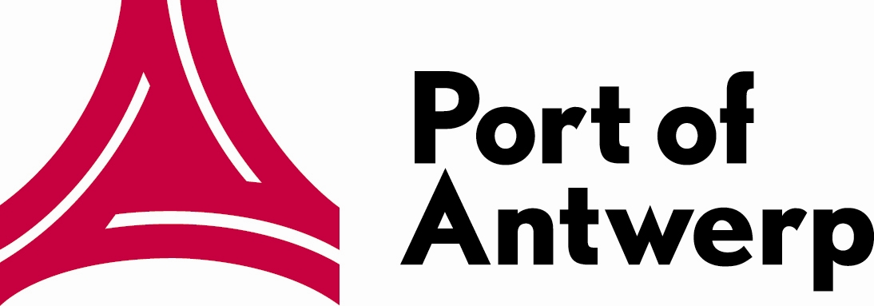
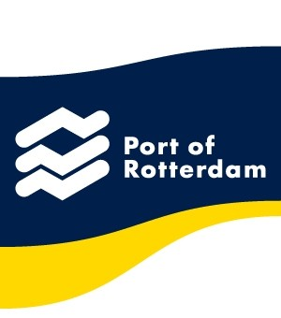


PRESS RELEASE JUNE 2013

21 and 22 November 2013 – Liège, Belgium

8th European Conference on Inland Terminals jointly hosted by Port of Liege, Port of Antwerp and Port of Rotterdam

After previous issues in Duisburg, Antwerp, Paris, Amsterdam, Marseille, Barcelona and Strasbourg the 8th ‘Inland Terminals’ Conference now moves to Liege, Belgium. The Port of Liege is Europe’s 3rd largest inland port, and in view of its close cooperation with the deep sea ports of Antwerp and Rotterdam it was decided to jointly point the limelight on the way these deep sea ports and the inland port interact in order to find “strategies to create value”, which is the main theme of the conference.

Previous issues of the conference investigated the strategy of seaports, deep sea terminal operators and liner shipping companies to include inland ports and terminals in their overall business development. Why is it that these inland ports have become an integral part of the strategy, how exactly do they fit in, and what will the future bring in this respect? How do key players of the three traditional modes (Rail-Road-Inland Waterways) react to this trend?
We also looked at traditional ports as “Value Centre Ports”, operating in the centre of a relational network aiming to create added value for all the nodes/players in the network. How can Inland Ports profit from such a relationship and how can they in turn create added value for other actors?
Connectivity was another topic. What does this mean in view of the current European policy? How does it affect local policy? What is the influence these policies have on players in the field? What is the benefit for shippers?

Program in detail - workshops
Apart from following up on these former issues the Liege conference specifically will dig deeper into the general theme: “strategies to create value”. Freight transport in the forthcoming decades is likely to increase by 60 %. European Commission member Jean-Eric Paquet will clarify what the EC’s policy is to avoid supply chain bottle necks and to reduce emissions. Is this policy in line with expectations from the European Federation of Inland terminals? Jean-Louis Jérôme, president of EFIP/FEPI provides the answers. How will the policy affect the different stakeholders, i.e. ship owners, terminal operators (Muriel Baugnée, Euroports Inland Terminals), forwarders and shippers? And what are their plans to create value in selecting inland consolidation hubs and creating and defining inland networks?
During the afternoon of the first day three separate but simultaneous workshops will be organised. Each one will be supervised by a qualified and experienced moderator and an expert in the field the workshop is dealing with. Moreover active participants will be invited to share first hand experiences. The topics of the workshops are varied. The first one, moderated by Bernard Piette (Logistics in Wallonia), will be headed “Emerging partnerships” and will provide answers to the following questions. What kind of cooperation are inland terminals setting up among themselves? What examples can be given? Are there new cross branch partnerships already in place or to be foreseen?
Sustainability is the topic of the second workshop. Several initiatives such as LNG and on shore power supply will be looked at. What is the added value? How does the market react? What are the real benefits for customers? Under the supervision of Jean-Louis Vandevoorde (ex-Lloyd) the third workshop investigates the relationship between deep sea terminals and inland ports/terminals in their hinterland. Among others the problem of solving the issue of empty depots is raised, along with the question if changed patterns influence the relationship and if so, to what extent and how.
The first day ends with a delivery on the results of the study “Long-term vision for inland ports” – “A toolbox for sustainable and connected port development” in the framework of “Connecting Citizen Ports 21”. This is followed by an exposé on the results of an economic and operational study on “Walloon inland container terminals and the sea ports of Antwerp and Rotterdam”.

Intermodal barge and rail networks
If the welcome speech of the first day is delivered by Willy Demeyer, Mayor of the city of Liege, but also President of the Liege Port Authority, on the second day delegates are welcomed by Carlo Di Antonio, Minister of Public Works, Agriculture, Rural Affairs, Nature, Forests and Heritage of the Walloon Government. The conference then continues with presentations concerning the innovation and development of intermodal barge and rail networks. How does such innovation contribute to value creation in inland terminals? In fact, how does an inland port develop its USP? What are the views in his respect of an inland transport organiser? Speakers include among others Tom Paeshuys (Liege Container Terminal) and Olivier Stevens (SOMEF).
Next item on the conference agenda deals with value creation from the perspective of inland terminals. An evaluation will be made of the TEN-T partnership between nine Upper-Rhine ports, a cross-border cooperation that was inaugurated nearly a year ago. How far have they come? What were the obstacles, if any, and what does the immediate and more distant future have in store for the project? Insight will also be given on how a functional inland terminal software management system can add value too.
The penultimate session of the conference sees the moderators of the workshops presenting their respective conclusions. And the three hosting partners, the ports of Liege, Antwerp and Rotterdam will summarize what knowledge they gained from the topics that were discussed over the past two days.

Ultimately, before conference chairman Karel Vanroye, Buck Consultants International, concludes the conference the final addresses will be held by Jean-Claude Marcourt, Vice-President and Minister of Economy, SMEs, Foreign Trade and New Technologies of the Walloon Government and Minister of Higher Education of the Government of the French Community, and by Dominique Riquet, Member of the European Parliament. Both will also witness a ceremonial signing of the aforementioned CCP21 study on “Long-term vision for inland ports”.

Exhibition and networking opportunities
An exhibition in support of the conference offers companies the possibility to be centre stage at the event. Conference delegates on their way to coffee breaks and lunch will walk through the exhibition and will have ample time to mix and mingle. Further networking opportunities are ensured by a cocktail party at the end of the first day, courtesy of Port of Liege, and also by a visit to the port following the end of the conference.
An attractive city as location calls for an attractive venue. The Palais des Congrès is located near the city centre, within easy reach of designated hotels. It offers state-of-the-art conference facilities and ample space for exhibiting companies.
The website www.inlandterminals.com is a source for further information; it is regularly updated to show developments of the conference program and the available exhibition space. The website also has online facilities to register for the event.

Paul Harding, Partner Confor bvba
Phone: +32 3 231.93.65 – E-mail: paul@confor.be

The conference logo and sponsor logos can be obtained in high resolution on demand.


Other contacts:
Port of Liege: Hélène Thiébaut, +32 4 232 97 85, h.thiebaut@portdeliege.be
Port of Antwerp: Danny Deckers, +32 3 205 20 89, Danny.Deckers@portofantwerp.com
Port of Rotterdam: Donald Baan, +31 10 252 15 97, D.Baan@portofrotterdam.com

